**DELHI TECHNOLOGICAL UNIVERSITY**



ALGORITHM DESIGN AND ANALYSIS

(CO-208)

SUBMITTED TO: SUBMITTED BY:

MR. SANJAY KUMAR ABHISHEK KUMAR SINGH (2K19/CO/021)

AMIT KUMAR JHA (2K19/CO/053)

OBJECTIVE

We came up with a system to simulate the parallel and serial computing and compare the two methods. We will read data and store it. Then we will calculate the moment of time when the processor began the processing of job for both serial and parallel computing methods. Then we will compare our result for the serial and parallel computing.

BASIC KNOWLEDGE / RELATED THEORY

Serial computing is a type of computation where instructions are executed sequentially one after another. In serial computing, a problem is broken into a series of instructions and the instructions are then executed sequentially one after another. Only one instruction may execute at any moment in time.

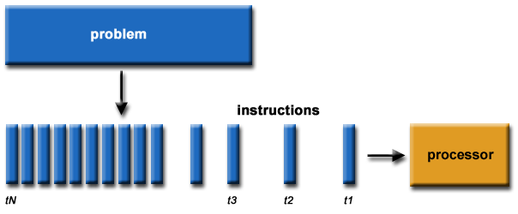

Parallel computing is a type of computation where many calculations or the execution of processes are carried out simultaneously. Large problems can often be divided into smaller ones, which can then be solved at the same time. There are several different forms of parallel computing: bit-level, instruction-level, data, and task parallelism. The objective of parallel processing is running a program in less time. Parallelism has long been employed in high-performance computing, but has gained broader interest due to the physical constraints preventing frequency scaling. As power consumption (and consequently heat generation) by computers has become a concern in recent years, parallel computing has become the dominant paradigm in computer architecture, mainly in the form of multi-core processors.

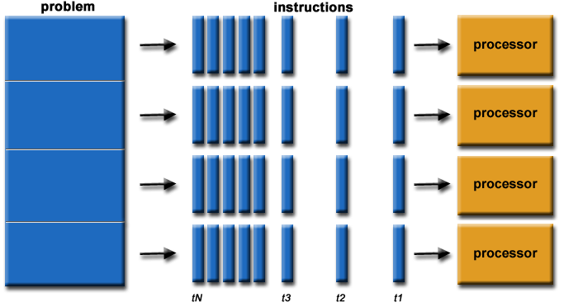

WORKFLOW

Reading data

Store the data in the required data structures

Passing the data to evaluation algorithm

Calculating the moment of time when the processor began processing the job

Displaying the result

Comparing the serial and parallel processing systems

TECHNOLOGY USED

C++

**C++** is a general-purpose programming language created by Bjarne Stroustrup as an extension of the C programming language, or "C with Classes". The language has expanded significantly over time, and modern C++ now has object-oriented, generic, and functional features in addition to facilities for low-level memory manipulation. It is almost always implemented as a compiled language, and many vendors provide C++ compilers.

REFERENCE PAPERS

<http://ijcsmc.com/docs/papers/May2014/V3I5201499a87.pdf>

<https://www.iosrjen.org/Papers/Conf.19021-2019/Volume-2/14.%2077-83.pdf>